
Expository Writing-LAB
Course Code: SL1014
Instructor: Ms. Huma Hafeez
Quiz 1:
Listening Skills Duration: 50 min
Total Marks :20 Weightage: -

Q1): Listening Skill Task [ 20]

SECTION 1. QUESTIONS 1-10
Questions 1-10
Complete the notes below.
Write NO MORE THAN TWO WORDS AND/OR A NUMBER for each answer.

BIRMINGHAM EXHIBITION

- Open in: 1. .
- Length of exhibition: 2. .
- A wide range of manufacturers will be showcased.
- Some cars are available to observe and others are for 3. .
- The 4. is prohibited to take into the museum.
- Every ticket includes one free photo.

- Price of the ticket: 5. £ (in advance).
- Transfer to Mark 6. (Box Office Manager).
- Held in the 7. Palace this year.
- Not far from 8. .
- Website: www. 9. .com.
- Best way to contact: 10. .

SECTION 2. QUESTIONS 11-20
Questions 11-15
Answer the questions below. Choose the correct letter, A, B, or C.
11. How many patients does the hospital consult every year?
- 3,000.
- 5,000.
- 11,000.

12. When can patients meet the female doctor?
- On weekday mornings.
- Three days a week.
- Only on Mondays and Fridays.

13. Who is the expert on treating hearing loss?
- Mr. Roberts.
- Mr Green.
- Mr. Edwards.
14. Where are patients recommended to buy their medicine?
- The supermarket in the town.
- Pharmacies nearby the city centre.
- The health care's pharmacy.
15. What will the patients be asked about whether they are willing to do?
- Letting one student attend the consultation.
- Asking postgraduate students to do treatment.
- Meeting students in group discussion.
Questions 16-20
Label the map below.
Write the correct letter, A-H, next to questions 16-20.
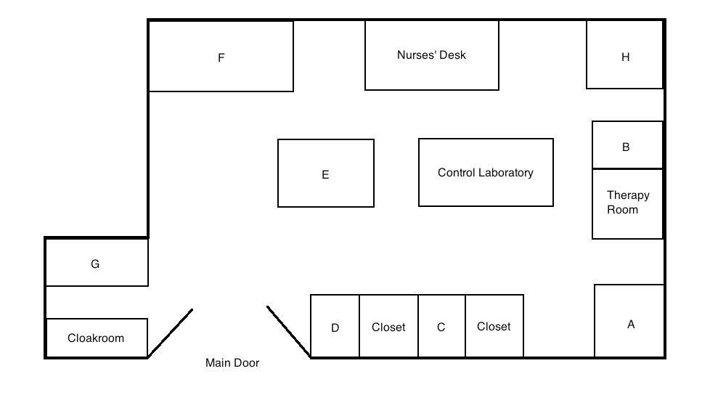
16. Reception
17. Mr. Green's room
18. Medical Records Office
19. Surgery Room
20. Manager's Office
SECTION 3. QUESTIONS 21-30
Questions 21-25 What is the main opinion of each of the following people?
Choose FIVE answers from the box and write the correct letter, A-G, next to questions 21-25.
Opinions
A lightning restrictions
B alternative lighting
C reduce the number of insects
D decline in the number of species
E climate changes
F impacts on the growth of animals
G imapcts on water quality
21. Ken Simpson
22. Dave Kepler
23. Sharon Grey
24. Maria Jackson
25. Barbara Swallow

Questions 26 and 27
Choose the correct letter, A, B or C.
26. What does Jim think about the difference among species in natural and artificial light?
- It makes no difference.
- Species will die out in natural light.
- Species will die out in artificial light.
27. One reason why Jim and Jane felt unsatisfied about the theories discussed in the lecture was that
- governments didn't increase any spending on them.
- most theories had nothing to do with the exam.
- many theories lack solid proof in the field.

Questions 28-30
Choose THREE letters, A-G.
Which THREE topics are they interested in studying in the future?
A quality of life tourism
В wildlife park animals
С migration birds
D animals living in rural areas
E animals living in tropical climate
F the impact of different environment on animals
G pandas in the zoo

SECTION 4. QUESTIONS 31-40
Questions 31 and 32
Choose TWO letters, A-E
Which TWO aspects did the new rules at the end of the 19th century focus on?
A cooperation
В competition
С moral values
D player's physical protection
E business model
Questions 33-40
Complete the sentences below.
Write ONLY ONE WORD for each answer.

Football in the UK

- At present the main reason why UK schools push football education is the preassure from 33. .
- Prior to the 19th, football players used different 34. of rules.
- People attempted to standardise the rules from the whole 35. , known as the 'Cambridge Rules' in 1848.
- Attendences were increasing due to the improvement of infrastructure and the 36. system.
- Football became popular and it is regarded as a 37. event.
- The football clubs were responsible for most of the 38. and development for the footbal association.
- 39. against other teams were also organised by the football clubs.
- In 1910s, 40. football players were approved of in the game.

